**Management of Processes and Resources**

**This program designs to manage multi processes and their resources. For every process you can make orders that will allow you to create a process, destroy a process, suspend a process, request a resource and release a resource.**

**Functions:**

**When you create a process you will give it and name and select the priority level. Then, the program will run the process which has a higher priority while other processes will be timeout.**

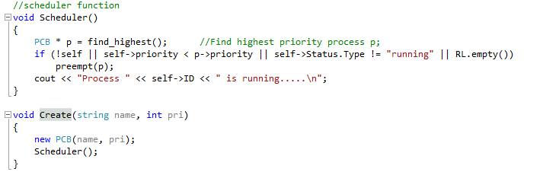

**When you destroy a process, the program will delete the running process and move to run the next higher level of priority. If resources of a process are used and you try to destroy the process, this will cause the program to crash. We can improve the program by sending the user first to release all request before destroy and process.**

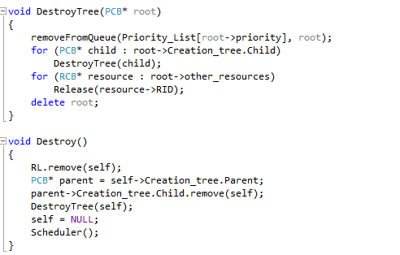

**When you suspend a process, the program will timeout the process is running then it will run it again after the timeout over. The program so far does not show how much time the timeout was, this could be improve to this program or we can allow user to set the timeout and run the next level of higher priority.**

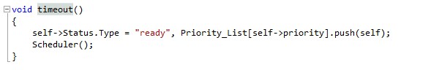

**When you request resources amount, the program will allow you to use the resources amount as long as it’s available. If the resources not available, the program will block the request and continue the same process.**

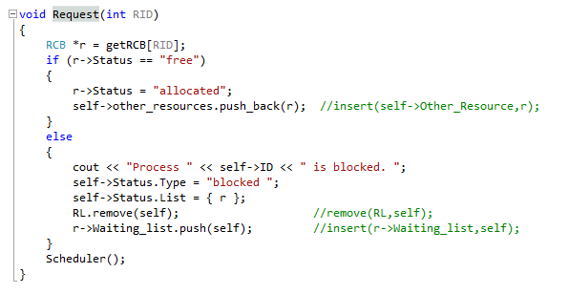

**When you release resources amount of a process, the program will allow make this amount available to request again. This function can be improved by checking if the resources used or not instead of check if the resources within main set value of resources. This will cause you to release resources even if they are not used.**

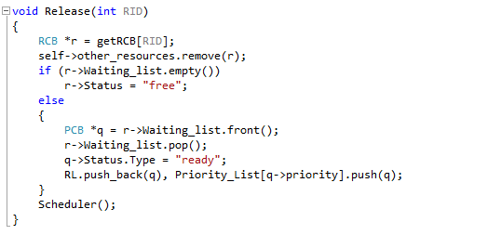

**Flow Diagram:**

**New state**

**none**

**ready**

**blocked**

**ready**

**Compiled and executed:**

* **Open code file (PP--3- Alajaj.sln) from program3 – Alajaj file. “this will open Visual studio 2013”**
* **To compile the code :**
  + **From top Manu bar : BUILD >> rebuild solution**
* **Now you will see this which mean to compiled correctly**

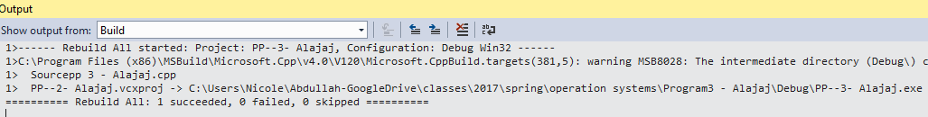

* **To execute the code : DEBUG >> start debugging or press F5**

**Result:**

* **Create 3 processes: A with priority of 50, B with priority of 40 and C with priority of 60**

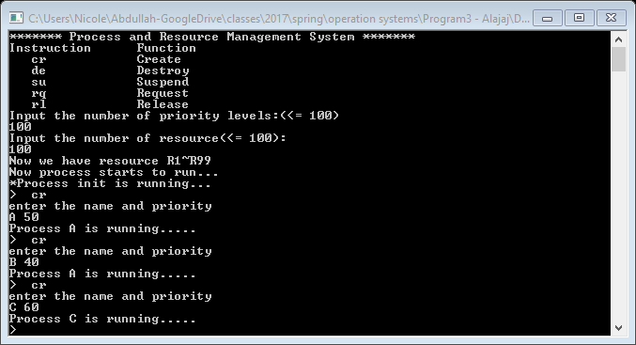

* **Now Destroy process C.**

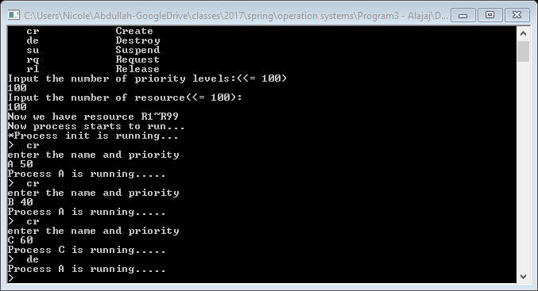

* **Request resources from A till there are not resources available**

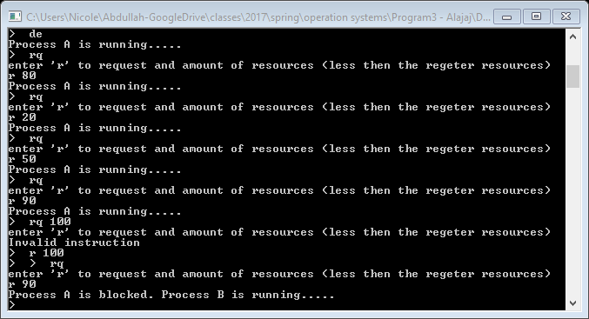

* **Release resources will make a running again**

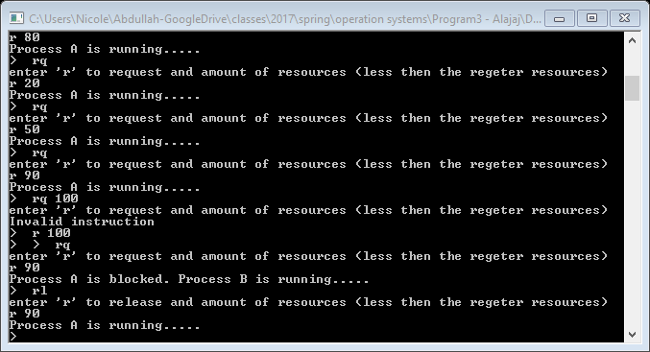

* **Destroy A while recourses still been used**

